

Body Bags and Infection Control Products
Catalog

Centennial Products, Inc.
Toll Free: (888) 604-1004 Fax: (904) 332-0406 Phone: (904) 332-0404
Internet Site: centennialproducts.com

Centennial Products, Inc. manufactures a wide range of body bags to fit the needs of the forensic, medical and funeral fields. We are able to offer many different styles from very small to very large, with and without handles, lined and unlined and both chlorine free material and vinyl. Being the manufacturer we are able to keep our quality control standards high and offer the best quality product for the best price.

Centennial Products, Inc. also offers to our customers a variety of morgue, field and lab supplies and personal protection products. Our catalog will provide you with the information and description of the products we offer. But if there is a product that you need, and cannot find, please do not hesitate to ask our customer service department for assistance.

Page Index

Product Category | Page Number
Post Mortem and Heavy Duty Body Bags | 01-05
Breathing, Eye and Face Protection | 06-09
Head Cover Protection | 10
Gowns, Lab Coats and Scrubs | 11
Tyvek ® and General Purpose Coveralls and Kits | 12-13
Shoe Cover and Boot Covers | 14-16
Lab Aprons and Sleeves | 17-18
Latex Gloves | 19-20
Non-Latex Gloves | 21
Disaster Response and Isolation Kits | 22
Morgue Supplies | 23-24
Morgue Instruments | 25-29
Evidence Collection Supplies | 30-32
Identification Supplies | 33-24

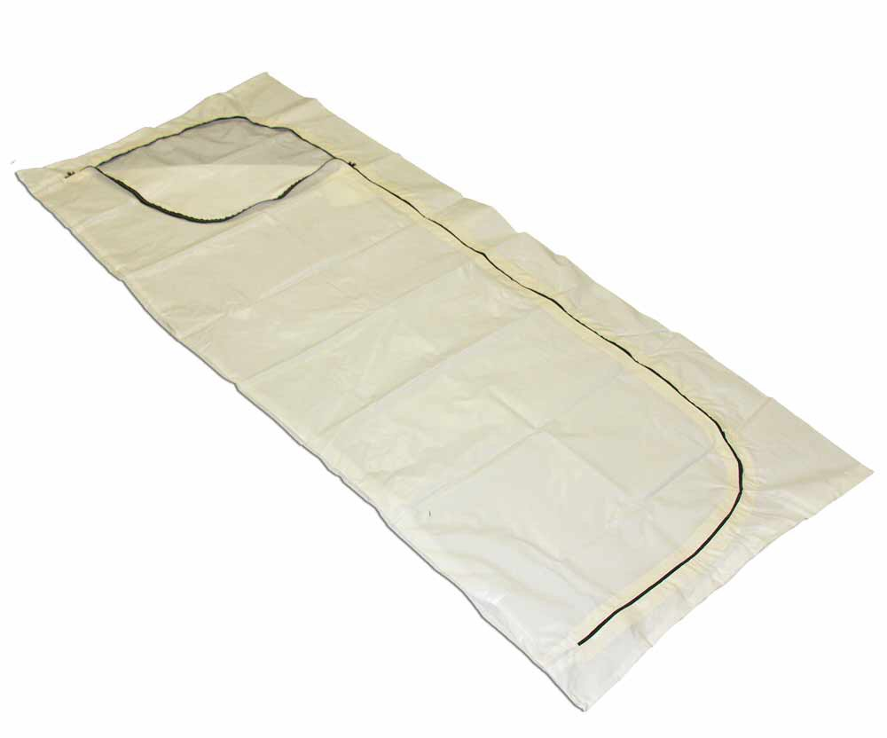
• | Electronically heat-sealed construction to comply with OSHA Regulation 3130 concerning universal precautions. Available in “envelope” style easy access zipper opening or “straight” zipper configurations
• | Constructed of the finest American made vinyl impregnated with a patented anti-microbial agent
• | Full-length rust resistant nylon zipper with dual zipper pulls
• | Extra long (96”) length by (38”) width
• | Each bag packed with BBID-KIT-T for field identification without the hassle of carrying separate  ID tags and supplies. Kit consists of tear proof Tyvek toe tags, exterior ID tag, personal effects ID tag, red biohazard tag and yellow contamination tags

Part Number | Color/Style | Quantity Per Case
BBDE-50 | WHITE-ENVELOPE VINYL | 24
BBDE-60 | BLACK-ENVELOPE VINYL | 24
BBDS-50 | WHITE-STRAIGHT VINYL | 24
BBDS-60 | BLACK-STRAIGHT VINYL | 24

The vinyl body bags described on this page are made with a PVC vinyl material. Caution should be used in the disposal of these bags as
vinyl gives off a chlorine gas when burned. All of our other body bags are manufactured using chlorine free material. Please follow all local
and federal regulations when disposing of these products.

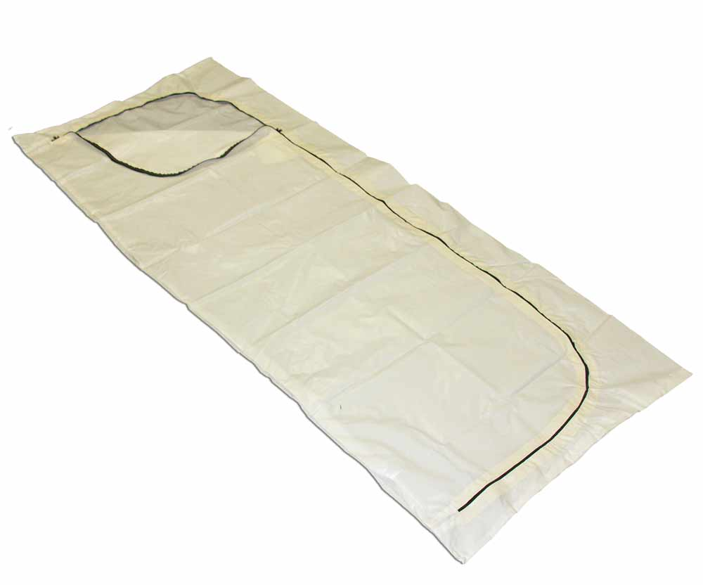

• | Same construction as our extremely popular BBDE-50-CF but without the scrim support material
• | Excellent choice for use in gurney to gurney type transport situations as well as donor and tissue services

Part Number | Color/Style | Quantity Per Case
BBDE-50CF-EC | WHITE-ENVELOPE | 24
BBDE-50CF-EC-BP | WHITE -ENVELOPE BULK PACK (NO ID TAGS) | 24

Toll Free: 888-604-1004 1 www.centennialproducts.com

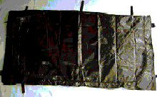

• | Same Heat Sealed “Bag-In-A-Bag” construction as our popular BBSDX-96-80 except exterior material  is 18 mil Heavy Duty Vinyl Coated Poly Scrim. Extra long (96”) length by (36”) width
• | 10 Ultra-Strong web handles for ease of handling by multiple individuals as well  as “litter style” carry in tight quarters by 2-4 individuals. Tested to 450 lb. lifting capacity
• | Large capacity envelope style heavy duty zipper with dual zipper pulls for easy access
• | Complies with OSHA Regulation 3130 for Universal Precautions involving containment of body  fluids and protection from blood borne pathogens
• | Each bag packed with BBID-KIT-T for field identification without the hassle of carrying separate  ID tags and supplies. Kit consists of tear proof Tyvek toe tags, exterior ID tag, personal effects ID  tag, red biohazard tag and yellow contamination tags

Part Number | Color/Style | Quantity Per Case
BBSDX-96HD-60 | BLACK-ENVELOPE | 6

The vinyl body bags described on this page are made with a PVC vinyl material. Caution should be used in the disposal of these bags as
vinyl gives off a chlorine gas when burned. All of our other body bags are manufactured using chlorine free material. Please follow all local
and federal regulations when disposing of these products.

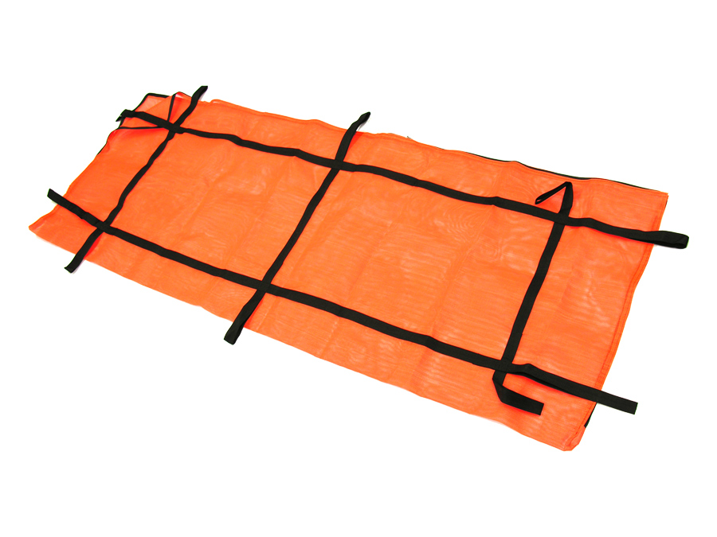

• | HIGH VISIBILITY orange vinyl coated polyester scrim mesh. Drains quickly once out of the water.
• | Perimeter zipper on three sides opens like a “clam shell” to allow ease of use in water recovery operations. Extra long (96”) length by (36”) width
• | 10 handled design allows ease of handling both in and out of the water
• | Each bag packed with BBID-KIT-T for field identification without the hassle of carrying separate ID tags and supplies. Kit consists of tear proof Tyvek toe tags, exterior ID tag, personal effects ID tag, red biohazard tag and yellow contamination tags

Part Number | Color/Style | Quantity Per Case
BBSDW-85 | ORANGE-ENVELOPE | 6

Toll Free: 888-604-1004 2 www.centennialproducts.com

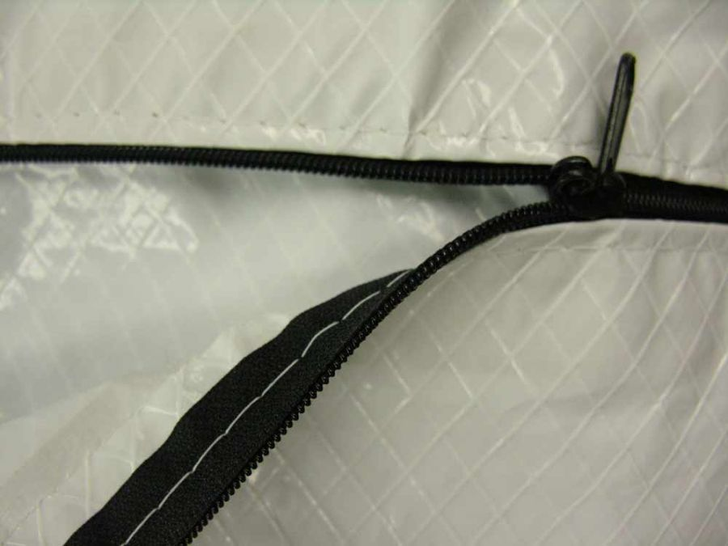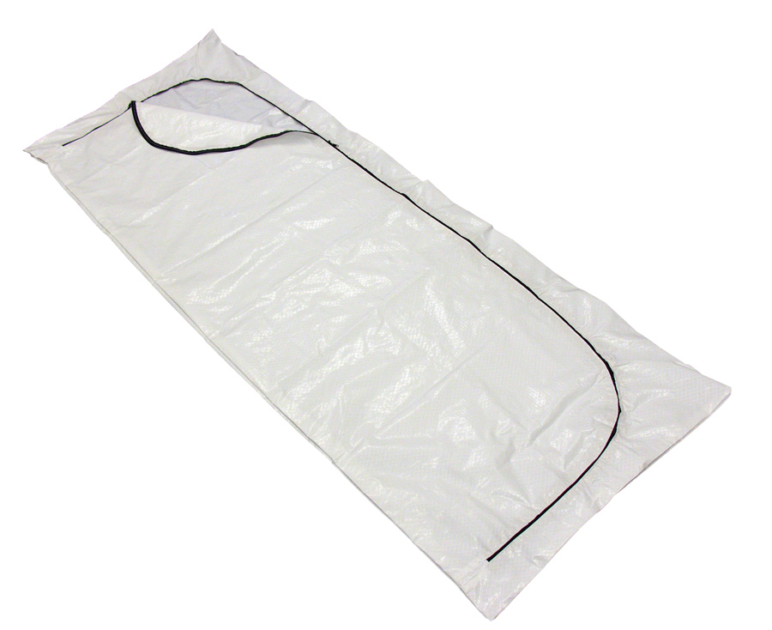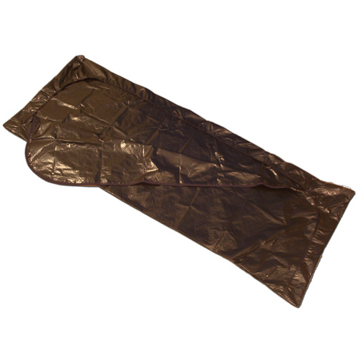

• | Electronic heat-sealed construction to comply with OSHA Regulation 3130
• | 2 layers of 3-mil polyethylene film laminated to 1000 denier scrim reinforced material  (equivalent strength to 12 mil vinyl). Environmentally EPA compliant.  No vinyl material used in manufacturing
• | Adhesive tape backed reinforced zipper to minimize possible “zipper tear-out” during  handling and transport. Dual zipper pulls to facilitate opening and closing bag
• | Chlorine Free material remains flexible to -70 degrees F. so that it can be used in  winter environments or morgue coolers without fear of material cracking.
• | Available in “envelope” style easy access zipper opening or “straight” zipper configurations
• | Each bag packed with BBID-KIT-T for field identification without the hassle of carrying separate ID tags and supplies. Kit consists of tear proof Tyvek toe tags, exterior ID tag, personal effects ID tag, red biohazard tag and yellow contamination tags

Part Number | Style-Zipper-Color-Type | Quantity Per Case
BBIM-50-CF | 12 X 18” STRAIGHT - WHITE (POSTMORTEM) | 12
BBIS-50-CF | 22 X 30” STRAIGHT - WHITE (INFANT) | 12
BBCS-50-CF | 36 X 60” STRAIGHT - WHITE (CHILD) | 12
BBDE-50-CF | 36 x 96” ENVELOPE – WHITE (ADULT) | 24
BBDE-50-CF-BP | 36 X 96” ENVELOPE – WHITE (ADULT NO BBID-T KIT) | 24
BBDE-60-CF | 36 X 96” ENVELOPE – BLACK (ADULT) | 24
BBDE-60-CF-BP | 36 X 96” ENVELPOPE – BLACK (ADULT NO BBID-T KIT) | 24
BBDS-50-CF | 36 X 96” STRAIGHT – WHITE (ADULT) | 24
BBDS-50-CF-BP | 36 X 96” STRAIGHT – WHITE (ADULT NO BBID-T KIT) | 24
BBDE-50-CF-XL | 48 X 100” ENVELOPE – WHITE (ADULT) | 12

The material used in the construction of the “CF” products is a “made in the U.S.A.” manufactured
material that eliminates the environmental problems associated with traditional vinyl materials used
in cadaver pouch construction. The “CF” material releases no chlorine gas when burned thereby
eliminating the disposal problems associated with vinyl materials.

Toll Free: 888-604-1004 3 www.centennialproducts.com

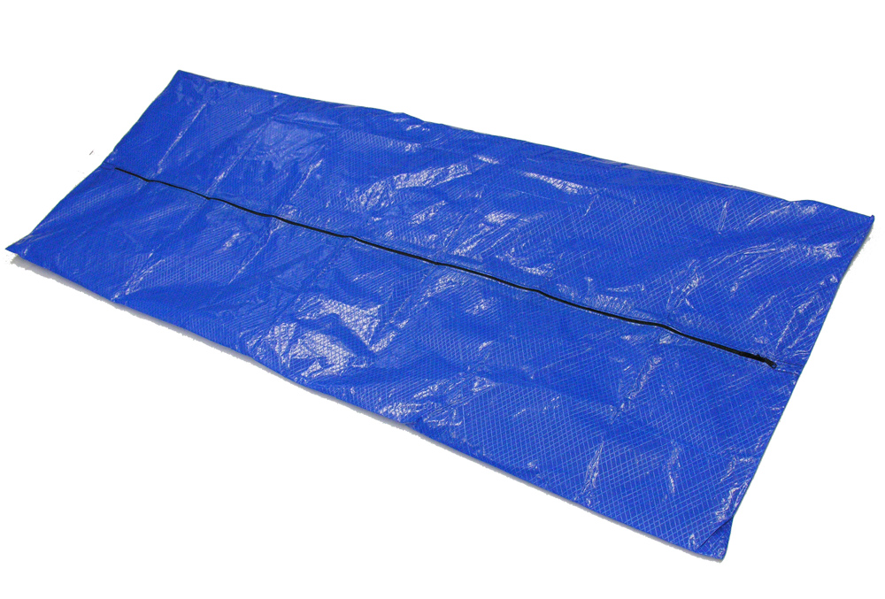
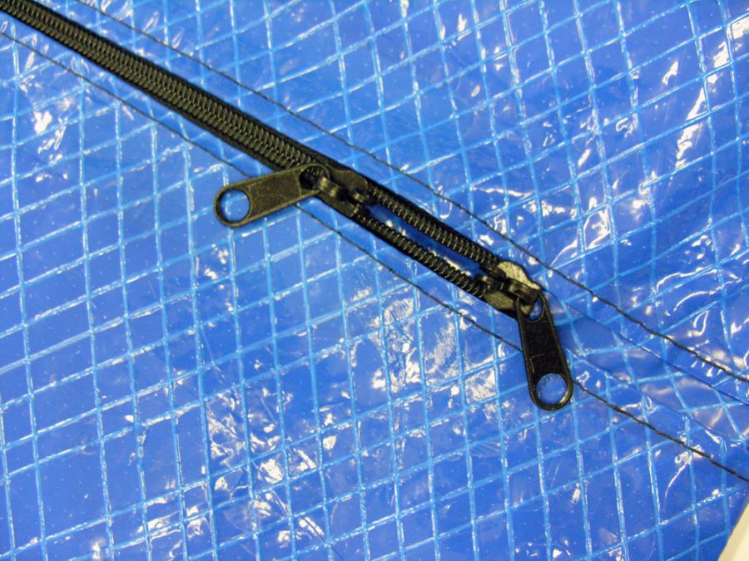

• | Electronic heat-sealed construction to comply with OSHA Regulation 3130
• | 2 layers of 3-mil polyethylene film laminated to 1000 denier scrim reinforced material  (equivalent strength to 12 mil vinyl). Environmentally EPA compliant.  No vinyl material used in manufacturing
• | Adhesive tape backed reinforced zipper to minimize possible “zipper tear-out” during  handling and transport. Dual zipper pulls to facilitate opening and closing bag
• | Chlorine Free material remains flexible to -70 degrees F. so that it can be used in  winter environments or morgue coolers without fear of material cracking.
• | These blue bags are a great way to distinguish bags among different agencies as well as being the preferred bag for photography.
• | Available in “envelope” style easy access zipper opening or “straight” zipper configurations
• | Depending on design bags are available with or without BBID-KIT-T for field identification without the hassle of carrying separate ID tags and supplies. Kit consists of tear proof Tyvek toe tags, exterior ID tag, personal effects ID tag, red biohazard tag and yellow contamination tags

Part Number | Style-Zipper-Color-Type | Quantity Per Case
BBDE-70-CF | 36 X 96” ENVELOPE – BLUE (ADULT) | 24
BBDE-70-CF-BP | 36 X 96” ENVELOPE – BLUE (ADULT NO BBID-T KIT) | 24
BBDS-70-CF-BP | 36 X 96” STRAIGHT – BLUE (ADULT NO BBID-T KIT) | 24

The material used in the construction of the “CF” products is a “made in the U.S.A.” manufactured
material that eliminates the environmental problems associated with traditional vinyl materials used
in cadaver pouch construction. The “CF” material releases no chlorine gas when burned thereby
eliminating the disposal problems associated with vinyl materials.

Toll Free: 888-604-1004 4 www.centennialproducts.com

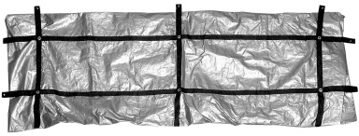

• | Exclusive Chlorine Free electronically heat-sealed “Bag-In-A-Bag” inner liner to prevent leakage  of fluids that may result from excess handling over rough terrain
• | Exterior made of chlorine free 12 mil “Super-Tough” polyethylene over polyester scrim material,  resists staining and is easily wiped clean
• | Large capacity envelope style heavy-duty zipper with dual zipper pulls for easy access, autopsy  can be performed in many cases without removal from the bag
• | Much longer shelf life than vinyl and remains flexible to –70° temperatures due to  non-vinyl polyethylene material
• | Each bag packed with BBID-KIT-T for field identification without the hassle of carrying separate ID  tags and supplies. Kit consists of tear proof Tyvek toe tags, exterior ID tag, personal effects ID tag,  red biohazard tag and yellow contamination tags
• | All lined bags comply with OSHA Regulation 3130 for Universal Precautions involving containment  of body fluids and protection from blood borne pathogens

Part Number | Color-Zipper Type-Style | Quantity Per Case
BBDE-80-CFX | 36 x 96” ENVELOPE – SILVER (ADULT)  (6 Handles without heat sealed inner liner) | 10
BBSDX-96-80 | 36 x 96” ENVELOPE – SILVER (ADULT)  (10 Handles with heat sealed inner liner) *Tested at 450 pounds | 10
BBSDX-80-48100 | 48 x 100” ENVELOPE – SILVER (EXTRA LARGE ADULT)  (10 Handles with heat sealed inner liner) * Tested at 750 pounds | 6
BBSDX-80-72108 | 72 X 108” ENVELOPE – SILVER (EXTRA LARGE ADULT) *Special Order**  (10 Handles with heat sealed inner liner) | 2
BBSDX-80-72120 | 72 X 120” ENVELOPE – SILVER (EXTRA LARGE ADULT) *Special Order*  (10 Handles with heat sealed inner liner) | 2
BBSDX-80-72132 | 72 X 132” ENVELOPE – SILVER (EXTRA LARGE ADULT) * Special Order*  (10 Handles with heat sealed inner liner) * Tested at 1200 pounds | 2

Toll Free: 888-604-1004 5 Fax: 904-332-0406

 Isolation Mask and Shield Combination
• | Polypropylene 3 micron isolation mask with attached 7 milanti-fog eye shield
• | Comfortable ear loop procedure or tie back mask design
• | Full width aluminum nose bridge band for good facial seal
• | Full “wrap around” shield design for maximum eye protection

Part No | Style | Color | Quantity Per Case
ALP-SM2005X | EARLOOP | BLUE | 100

Isolation Ear Loop Procedure Mask
• | Polypropylene 3 micron isolation mask
• | Comfortable ear loop or with 7” ties
• | Full width aluminum nose bridge band for good facial seal

Part No | Style | Color | Quantity Per Case
ALP-BL5005 | UNIVERSAL-EARLOOP | BLUE | 500
ALP-BL6001 | UNIVERSAL-7” TIES | BLUE | 300

Toll Free: 888-604-1004 6 Fax: 904-332-04

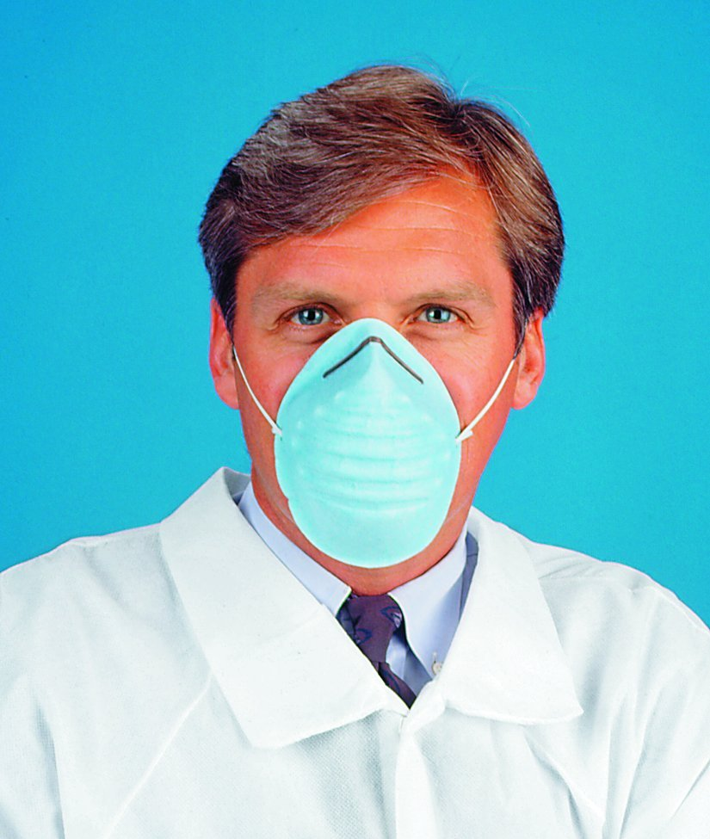

Cone Style General Procedure Mask
•

Cone style mask w/elastic head band. Easy to don and comfortable to wear
• | Aluminum nose bridge clip for good facial seal
• | Better than 95% BFE filtration protection

Part No | Style | Color | Quantity Per Case
ALP-BL2020 | UNIVERSAL | BLUE | 300

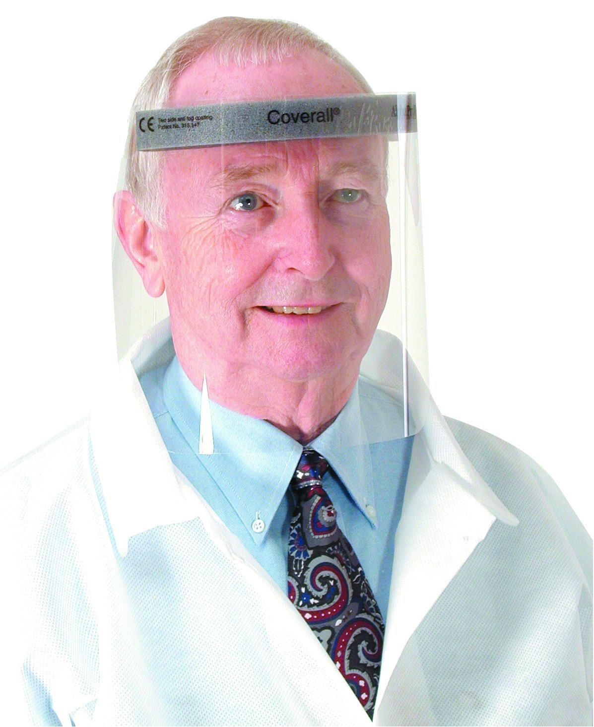 Anti-Fog Face Shields
•

Premium 7 mil optical grade anti-fog film face shield material
• | Soft foam perspiration forehead cushion
• | Soft elastic comfort band for comfortable long-term use or adjustable Velcro style headband
• | Conforms to OSHA and CDC recommended facial protection

 | Part No | Style | Color | Quantity Per Case
 | ALP-2807 | COMFORT BAND | CLEAR | 100
 | ALP-2802 | VELCRO BAND | CLEAR | 100

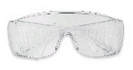 Anti-Splash Safety Glasses
 | • | Polycarbonate high impact resistant UV protective lens with anti-splash side panels. Fits over most prescription glasses
 | • | Conforms to OSHA and CDC recommended facial protection
Part No |  |  | Style | Color | Quantity Per Case
EYEPROT-90S |  |  | UNIVERSAL | CLEAR | 12

Toll Free: 888-604-1004 7 Fax: 904-332-0406

• | Magic Arch® polypropylene strips encased in mask material to provide a comfortable breathing chamber as well as Positive Facial Lock design
• | Aluminum strips on both top and bottom to ensure a custom fit and seal. Fluid resistant outer facing with cool, soft inner material.
• | Mask material is fiberglass and latex free with comfortable dual knit elastic headbands
• | NIOSH Approved Universal “One-Size-Fits-All” Design. No need to stock multiple size masks for each use
• | High filtration efficiency with a BFE at over 99% at .1 micron
• | Packed 35 units per box - 6 boxes per case

Part No | Size | Color | Quantity Per Case
ALP-695 | UNIVERSAL | TEAL/WHT | 210



Respirator Donning Procedures

Step 1
Grasp nosepiece at the top of mask with one hand. Slide finger of other hand behind chin piece.

Step 2
Open mask by pulling down and out on chin piece until mask is fully open. Place chin in pocket created. Stretch bands over back of head, positioning bottom band behind neck below ears and
top band near crown of head.

Step 3
Conform nosepiece to nose and face contours making sure Magic Arch is fully extended providing maximum clearance from nose and mouth.

Step 4
Holding mask at nosepiece, place one finger inside the mask on the malleable aluminum chin piece. Pull down gently so that mask is snug against the face.

Step 5
Pinch any excess material together under chin and fold over or twist.

To check fit, place both hands along edges of the respirator and exhale. If air escapes around your nose, adjust nosepiece. If air leaks at the respirator edges, unfold or untwist the chin
piece and repeat step 4 and 5 above.

The N-95 Particulate Respirator is NIOSH approved and meets CDC and WHO guidelines.

Toll Free: 888-604-1004 8 www.centennialproducts.com

North N95 Respirator
• | Disposable Dust/Mist N95 Respirator
• | Provides protection from solids and particulate aerosols free of oil and an ideal product for dusty environments involved with grinding, sanding, and sweeping

Part No | Size | Color | Quantity Per Case
NOS-713N95 | ADJUSTABLE W/OUT VALVE | WHITE | 20
NOS-714N95 | ADJUSTABLE W/ VALVE | WHITE | 10

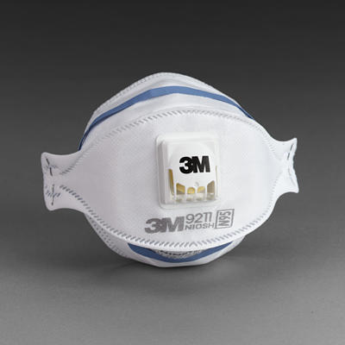 3M™ N95 Disposable Mask w/Valve
• | Innovative three-panel design allows you to fold the respirator for easy transport
• | Traps 95% of non - oil based particles and meets NIOSH 42 CFR 84 N95 Requirements
• | Cool Flow Exhalation Valve helps reduce heat and humidity inside the mask
• | Adjustable M-nose clip provides a secure seal against the face

Part No | Size | Color | Quantity Per Case
3M-9211-N95MASK | ADJUSTABLE W/ VALVE | WHITE | 10

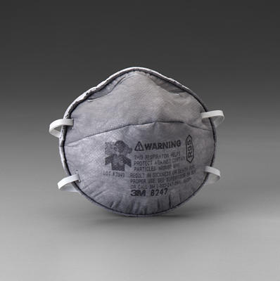 3M™ R95 Disposable Mask w/out Valve
• | Particulate Respirator with Nuisance Level Organic Vapor Relief Valve
• | Certified to provide at least 95% efficiency against solid and liquid particulates

Part No | Size | Color | Quantity Per Case
3M-8247-R95MASK | FIXED ELASTIC STRAPS | GRAY | 20

Toll Free: 888-604-1004 9 www.centennialproducts.com

 Spunbond Bouffant Caps
• | Spunbond poly-pro material w/non-binding elastic headband
• | Comfortable and cool to wear
• | Provides splash or mist fluid protection

Part No | Size | Color | Quantity Per Case
CAP-120070-SB-21 | 21” | BLUE | 500
CAP-120050-SB-21 | 21” | WHITE | 500
CAP-120070-SB-24 | 24” | BLUE | 500
CAP-120050-SB-24 | 24” | WHITE | 500

  Tyvek® Bouffant Cap
•

Tyvek® material w/non-binding elastic headband
• | Provides greater fluid protection than the spunbond bouffant caps above

Part No | Size | Color | Quantity Per Case
CAP-80221-TVK | 21” | WHITE | 500
CAP-80224-TVK | 24” | WHITE | 500

 Surgeon Cap
•

Scrim reinforced fabric material w/ties
• | Comfortable splash and mist protection

Part No | Size | Color | Quantity Per Case
CAP-SURG-B | UNIVERSAL | BLUE | 500

Toll Free: 888-604-1004 10 Fax: 904-332-0406

 Poly-Film Thumb Hole Gown
• | All poly film impervious material
• | Same thumb hole design as our deluxe impervious gown above
• | Easy “slip-on” boatneck style collar and open back design for easy donning

Part No | Size | Color | Quantity Per Case
GOWN-8572B | UNIVERSAL | BLUE | 100

Spunbond Poly (Non-Coated) Isolation Gown
•

Semi-impervious spunbond tie back isolation gown
• | Elastic sleeves and below knee length

Part No | Size | Color | Quantity Per Case
GOWN-155075-UNIV | UNIVERSAL | YELLOW | 50

 Disposable Scrubs
•
PC Coolwear pants with tie waist
• | Shirt has round collar, pocket and short sleeves. Both shirt and pants are available in sizes Small – XL
Also Available in Alpha Softwear

Part No | Size | Color | Quantity Per Case
PCSCRUB-1518-P-XX | SMALL – X-LARGE | BLUE | 50
PCSCRUB-1517-S-XX | SMALL – X-LARGE | BLUE | 50

Toll Free: 888-604-1004 11 www.centennialproducts.com



 Tyvek® Basic Coverall

• | Tyvek® Coverall w/Elastic Wrist and Ankles. Full front nylon zipper. Semi - Impervious

Part No | Size | Color | Quantity Per Case
CVRALL-1417 | SMALL – 5XL | WHITE | 25

 Tyvek® Coverall With Hood and Boots
• | One piece Tyvek® Suit w/Attached Hood and Anti-Skid Boots w/ full front nylon zipper
• | Semi-Impervious

Part No | Size | Color | Quantity Per Case
CVRALL-1414 | SMALL - 5XL | WHITE | 25

 Tyvek® QC Coverall With Hood and Boots
• | One piece Tyvek® QC Suit w/Attached Hood and Boots
• | Full front nylon zipper and elastic wrists. Impervious Poly Coated Material

Part No | Size | Color | Quantity Per Case
CVRALL-5414 | SMALL – 5XL | YELLOW | 25

Toll Free: 888-604-1004 12 Fax: 904-332-0406



 MicroMax® Basic Coverall

• | Micromax® Coverall w/Elastic Wrist and Ankles. Full front nylon zipper.
• | Scrim reinforced for superior strength

Part No | Size | Color | Quantity Per Case
CVRALL-TG1417 | SMALL – 5XL | WHITE | 25

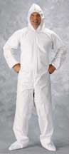 MicroMax® Coverall With Hood and Boots
•

One piece Micromax® Suit w/Attached Hood and Anti-Skid Boots
• | Full front nylon zipper. Scrim reinforced for superior strength

Part No | Size | Color | Quantity Per Case
CVRALL-TG1414 | SMALL - 5XL | WHITE | 25

Superior microporous protection at a very affordable cost!
MicroMAX® is the most advanced microporous technology in the protective clothing market yet. This line of general purpose protective clothing can be used in any non-hazardous environment where dirt, grime, splashes and spills are present. The MicroMAX® fabric is comprised of a microporous film with a nylon scrim between the film and substrate that gives the material additional strength.
Tough can-do protection at a price that is sure to agree with your budget

• Economical

• Great Barrier

• Excellent abrasion
resistance

• Liquid splash and dry
particulate protection

• Scrim reinforced for
superior strength

Test Conducted by Independent Lab Using ASTM F903 on Chemicals & ASTM F1670-97a on Blood

Chemical Tested | Concentration % | Test Time Mins. | Results
Sodium Hydroxide 50% | 50 % | 60 | Pass
Sodium Hypochloride | 10 % | 60 | Pass
Blood | Challenge Fluid Titer  3.20 x 10^8 *PFU/ml | Assay Results  PFU/ml <1 | Pass

Toll Free: 888-604-1004 13 www.centennialproducts.com

 Anti-Skid Shoe Covers

• | Spunbond polypropylene semi-impervious material w/ Anti-Skid rubber sole for good traction and workplace safety

Part No | Size | Color | Quantity Per Case
SHOECVR-110070-UNI | UNIVERSAL | BLUE | 300
SHOECVR-110070-XL | XL | BLUE | 200

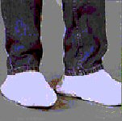 Tyvek® Anti-Skid Shoe Covers

• | Elastic top shoe cover made of Dupont Tyvek® Anti-Skid Material Semi-Impervious for wet or dry floor use

Part No | Size | Color | Quantity Per Case
SHOECVR-901NS-UNIV | SM/MED | GRAY | 400
SHOECVR-901NS-XL | LG/XL | GRAY | 400
SHOECVR-901NS-2X | 2X | GRAY | 400

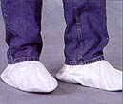 Tyvek® Shoe Covers With Vinyl Sole

• | Dupont Tyvek® Upper, Vinyl sole, Elastic ankles and top

Part No | Size | Color | Quantity Per Case
SHOECVR-904-XL | XL | WHITE | 400

Toll Free: 888-604-1004 14 www.centennialproducts.com

 Aqua Trak® Impervious Shoe Cover

• | High quality poly coated spunbond material. Seams are heat sealed to make this shoe cover as impervious as possible while still offering safe, comfortable protection

Part No | Size | Color | Quantity Per Case
SHOECVR-AT21112-B | XL | WHITE | 150
SHOECVR-AT11112-B | XL | BLUE | 150

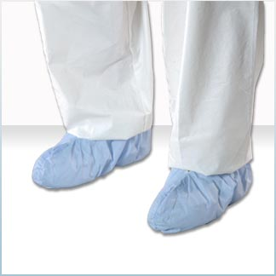 SUREGRIP Shoe Cover

• | Non-skid general purpose; Spunbond Poly

Part No | Size | Color | Quantity Per Case
SHOECVR-SHX1224B | 2X | BLUE | 300

 Tyvek® Boot Covers With Vinyl Sole

Elastic top and ankles boot cover made of Dupont Tyvek®
Semi-Impervious for wet or dry floor use

Part No | Size | Color | Quantity Per Case
BOOTCVR-905-XL | 15” UPPER | GRAY | 400
BOOTCVR-907-XL | 20” UPPER | GRAY | 400

Toll Free: 888-604-1004 15 www.centennialproducts.com

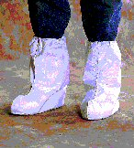 Tyvek® Anti-Skid Boot Covers

• | 15" High elastic top boot cover made of Dupont Tyvek® Special Anti-Skid Material
• | Semi-Impervious for wet or dry floor use

Part No | Size | Color | Quantity Per Case
BOOTCVR-903NS-SMED | SM/MED | GRAY | 400
BOOTCVR-903NS-LGXL | LG/XL | GRAY | 400
BOOTCVR-903NS-2X | 2X | GRAY | 400

 Aqua Trak® Impervious Boot Cover

High quality poly coated spunbond material

Seams are heat sealed to make this boot cover as impervious as possible while still offering safe, comfortable skid resistant workplace protection

Part No | Size/Style | Color | Quantity Per Case
BOOTCVR-BT91412-B | UNIVERSAL/23” | BLUE | 200
BOOTCVR-BT91413-B | XL/23” | BLUE | 200
BOOTCVR-BT91X13-B | XL/ANKLE HIGH | BLUE | 200

Toll Free: 888-604-1004 16 www.centennialproducts.com

 Tyvek® Aprons and Sleeve Protectors

• | Apron is 28” Wide x 36” Long with sewn ties
• | Sleeves are 18” long and have elastic top, cuffs and sewn seams
• | Sleeve protectors and aprons are made of Dupont Tyvek® Material

Part No | Size | Color | Quantity Per Case
APRON-601 | 28 X 36” | WHITE | 100
SLEV-85018 | 18” | WHITE | 200

 Tyvek® QC Aprons and Sleeve Protectors

• | Apron is 28” Wide x 36” Long with sewn ties
• | Sleeves are 18” long and have elastic top, cuffs and sewn seams
• | Sleeve protectors and aprons are made ofDupont Tyvek® QC Poly Coated Impervious Material

Part No | Size | Color | Quantity Per Case
APRON-650 | 28 X 36” | YELLOW | 100
SLEV-86018 | 18” | YELLOW | 200

Toll Free: 888-604-1004 17 www.centennialproducts.com

 Poly Lab Apron

• | 1.75 mil polyethylene general purpose lab apron
• | Apron has neck strap and waist ties
• | Packed 100 units per case

Part No | Size | Color | Quantity Per Case
APRON-54290 | 28 X 45” | WHITE | 100

 Impervious Thumbhole Sleeve Protector

• | 22" sleeve protectors made of Coated Spunbond Material
• | Impervious material with elastic top and cuff Heat Sealed Seams
• | Packed 200 units (100 pairs) per case

Part No | Size | Color | Quantity Per Case
SLEV-2270-TH | 22” | BLUE | 200

Toll Free: 888-604-1004 18 www.centennialproducts.com

General Purpose Latex Exam Glove

• | 7 mil – 9.5” Length Smooth finish
• | Packed 100 per box - 10 boxes per case *SIZES XS, SM, MED, LG OR XL

Part No | Style | Color | Quantity Per Case
GLV-DC-LP* | LT POWDERED | NATURAL LATEX COLOR | 1,000
GLV-DF-PF* | POWDER FREE | NATURAL LATEX COLOR | 1,000

OptiGrip Plus Latex Exam Glove

• | 8 mil – 9.5” Length Textured finish, Single chlorinated
• | Packed 100 per box - 10 boxes per case *SIZES XSM, SM, MED, LG, XL

Part No | Style | Color | Quantity Per Case
GLV-DFO-PF* | POWDER FREE | NATURAL LATEX COLOR | 1,000

BarrierMax™ Long Cuff Latex Exam Glove

• | 12 mil – 12” Length Textured finish, non chlorinated
• | NFPA 1999-2003 Certified
• | Packed 50 per box – 10 boxes per case *SIZES SM, MED, LG OR XL,XXL,XXXL

Part No | Style | Color | Quantity Per Case
GLV-BMAX-PF* | POWDER FREE | NATURAL LATEX COLOR | 500

ICU911™ EMS High Risk Latex Long Cuff Glove

• | 10 mil – 12” Length Textured Finish
• | NFPA 1999-2003 Certified
• | Packed 50 per box – 10 boxes per case *SIZES SM, MED, LG, XL, XXL

Part No | Style | Color | Quantity Per Case
GLV-ICU911-PF* | POWDER FREE | NATURAL LATEX COLOR | 500

Toll Free: 888-604-1004 19 www.centennialproducts.com

HaloKote HD Chemotherapy Latex Glove

• | Green High-Risk Toxic Chemical Resistant Glove
• | 16.5/14.4 mil with 12” cuff
• | Packed 50 per box – 10 boxes per case *SIZES SM, MED, LG OR XL

Part No | Style | Color | Quantity Per Case
GLV-DSK-PF* | POWDER FREE | GREEN | 500

Safegrip™ Latex Glove

• | Textured High Risk Latex Exam Glove
• | 16.1 mil textured fingertips with 11” cuff
• | Packed 50 per box – 500 per case *SIZES SM, MED, LG OR XL

Part No | Style | Color | Quantity Per Case
GLV-G375* | POWDER FREE | BLUE | 500

Diamond Grip™ Latex Glove

• | Textured Fingertips with Beaded Cuff
• | 8.7/6.3 mil with 9” cuff
• | Packed 100 per box – 1000 per case *SIZES SM, MED, LG OR XL

Part No | Style | Color | Quantity Per Case
GLV-MF300* | Powder Free | Natural | 1000

Diamond Grip Plus™ Latex Glove

• | Textured Fingertips and Palm with Beaded Cuff
• | 7.1/6.3 mil with 9” cuff
• | Packed 100 per box – 1000 per case *SIZES SM, MED, LG OR XL

Part No | Style | Color | Quantity Per Case
GLV-DGP350* | Powder Free | Natural | 1000

** If the gloves you are looking for are not shown please contact customer service for availability **

Toll Free: 888-604-1004 20 www.centennialproducts.com

Frontline™ Nitrile Glove

• | White High-Risk Powder Free Nitrile Exam Glove
• | 6/5 mil palm 9” or 12” 4 mil cuff with textured grip-tight fingers
• | Packed 100 per box – 10 boxes per case * SIZES SM, MED, LG, XL or 2XL (2XL 900/CS)

Part No | Style | Color | Quantity Per Case
GLV-FL9-PF* | 9” CUFF NITRILE | WHITE | 1,000
GLV-FL12-PF* | 12” CUFF NITRILE | WHITE | 1,000

High-Risk Nitrile Glove

• | Purple High-Risk Long Cuff Powder Free Nitrile Exam Glove
• | 6 mil palm 12” cuff with textured grip-tight fingers
• | Packed 50 per box – 10 boxes per case * SIZES – SM, MED, LG, XL

Part No | Style | Color | Quantity Per Case
GLV-5060* | POWDER FREE | PURPLE | 500

Safeknit Spectra® Cut Resistant Glove

• | Soft and Comfortable Spectra® Fiber Material
• | Excellent cut resistant properties yet allows good tactile feel
• | Stands up to laundering even with bleach
• | Worn as a liner under exam or autopsy gloves *SIZES – 5, 6, 7, 8, 9, 10, 11

Part No | Style | Color | Quantity Per Case
GLV-72025* | CUT RESISTANT | WHITE | 12

Fingerless Glove Mate

• | Versatile one size fits all ambidextrous glove liner made from 100% cotton
• | Highly absorbent, the Glove Mate™ Liner provides added protection against chafing and dry skin commonly caused by hand perspiration.

Part No | Style | Color | Quantity Per Case
GLV-RAD64057268 | FINGERLESS LINER | TAN | 100

Toll Free: 888-604-1004 21 www.centennialproducts.com

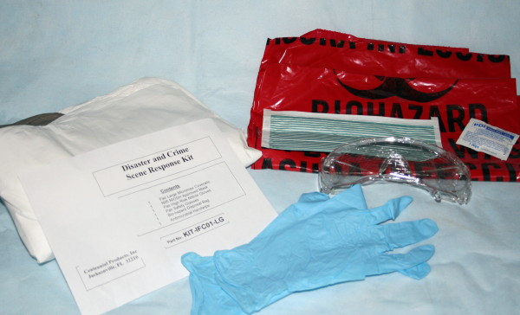 Disaster Scene Response Kit

Kit Contains
• | Micromax® Coverall w/Hood, Boots, Elastic Wrist and Ankles
• | Pair of X-Large Nitrile Gloves | • | N95 NIOSH Respirator
• | Pair of Safety Glasses | • | Bio-Hazard Disposal Bag

Part No | Size | Color | Quantity Per Case
KIT-IFC-01 | XL | WHITE | 10
KIT-IFC-01-2X | 2X | WHITE | 10

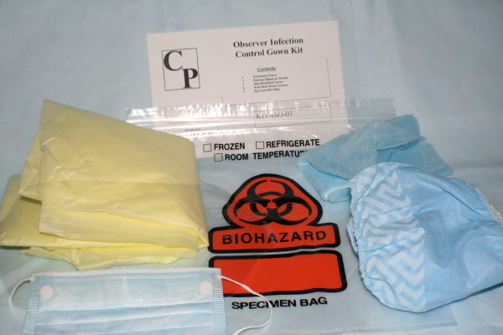 Observer Isolation Kit

Kit Contains
• | Universal Spunbond Open Back Yellow Isolation Gown w/Ties
• | Combination Mask w/Eye Shield | • | Anti-Skid Shoe Covers
• | Bouffant Cap and Ziploc Bio-Hazard Disposal Bag

Part No | Size | Color | Quantity Per Case
KIT-ISO-01 | UNIVERSAL | YELLOW | 50

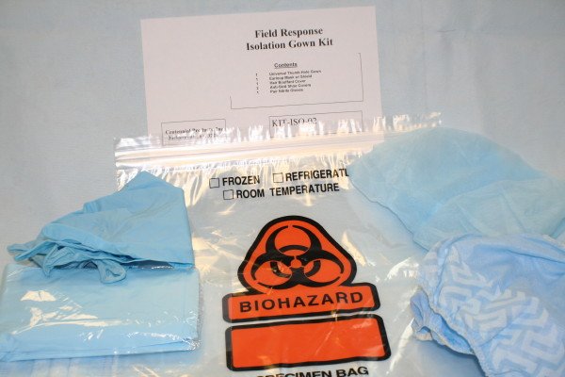 Scene Response or Observer Isolation Kit

Kit Contains
• | Universal Poly Film Thumbhole Open Back Isolation Gown w/Ties
• | Combination Mask w/Eye Shield | • | Anti-Skid Shoe Covers
• | 1 Pair Nitrile 6 mil High-Risk exam gloves ; bouffant cap and Ziploc Bio-Hazard Disposal Bag

Part No | Style | Color | Quantity Per Case
KIT-ISO-02 | UNIVERSAL | BLUE | 50

Toll Free: 888-604-1004 22 www.centennialproducts.com

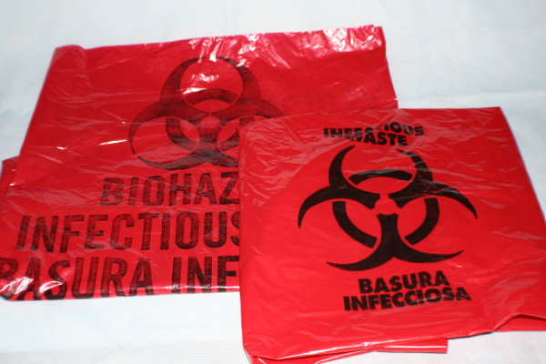 Bio-Hazard Waste Disposal Bags

• | Polyethylene Bio-Hazard waste disposal bag. Printed with both English and Spanish text

Part No | Style | Color | Quantity Per Case
PBAG-23x24x2-BIO | 23 X 24” X 2 mil | RED | 250
PBAG-33X39X2-BIO | 33 X 39” X 2 mil | RED | 100

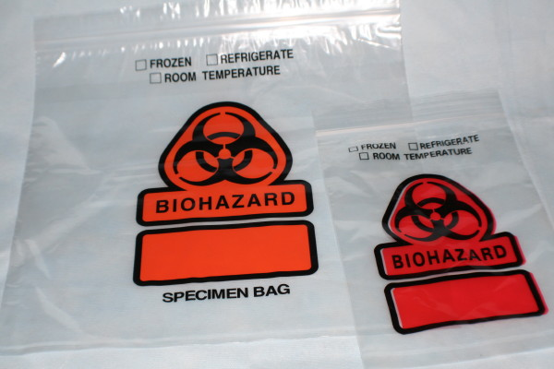 Bio-Hazard Waste Specimen Bags

• | Imprinted Bio-Hazard Logo. Convenient paperwork compartment.

Part No | Style | Color | Quantity Per Case
PBAG-06X09ZIPBIO | 3 WALL ZIPLOCK | CLEAR | 1000
PBAG-12X12ZIPBIO | 3 WALL ZIPLOCK | CLEAR | 1000

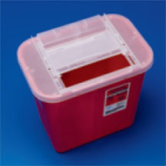 Multipurpose Sharps Containers

• | Non-tortuous lid design accommodates a variety of sizes of sharps
• | Translucent lid allows staff to identify fill levels quickly; Each container locks for final disposal

Part No | Style | Color | Quantity Per Case
SHARPS-MDS709110H | 1 QUART | RED | 1
SHARPS-MDS705125H | 2.5 QUART WALL MOUNT | RED | 1
SHARPS-MDS705152H | 5 QUART | RED | 1
SHARPS-MDS705201H | 1 GALLON | RED | 1
SHARPS-MDS702120RH | 2 GALLON | RED | 1
SHARPS-MDS709135 | 11 GALLON | RED | 6
SHARPS-PSS16506 | 7.5 Gallon Round w/lid and carry handle | RED | 6

Toll Free: 888-604-1004 23 www.centennialproducts.com

 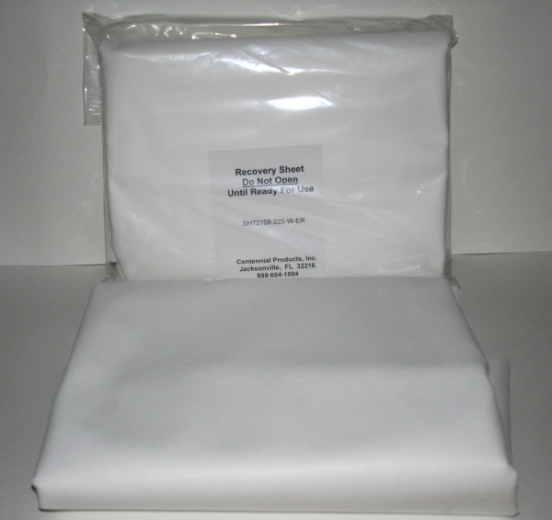 Morgue & Scene Sheets
• | Heavy Poly Propylene spunbond semi-impervious material
• | Strong enough to transfer heavy individuals
• | Non-sterile

Part No | Style | Color | Quantity Per Case
SH-072108-225W | 72 x 108”  Bulk Pack | WHITE | 25
SH-072108-EVR-W | 72 x 108”  Individually Wrapped | WHITE | 25

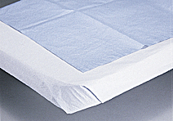

Stretcher and Exam Sheets

• | Stretcher Sheets; Tissue; Poly; 40 x 90
• | Exam Sheets; Tissue/ Poly Laminate; 20 x 40

Part No | Style | Color | Quantity Per Case
MED-NON24335 | Stretcher Sheet | Blue | 50
MED-LPC80923 | Exam Sheet | Blue | 200

10% or 20% NB Formalin

• | Neutral Buffered, pH 7.0
• | Use in histological applications to fix and store tissue specimens and also for use in tissue processors
• | Rapid acting and permits the use of a broad spectrum of staining methods

Part No | Style | Type | Quantity Per Case
ASTRAL-3322 | 10% | 5 GALLON REAGENT CUBE | 1
ASTRAL-3321 | 10% | 1 GALLON REAGENT | 1
ASTRAL-3299-5 | 20% | 5 GALLON REAGENT | 1

Toll Free: 888-604-1004 24 www.centennialproducts.com

 Specimen Needles

• | 304 Surgical Stainless Steel
• | Standard Luer-Lock Hub made of alcohol resistant clear polycarbonate
• | Proprietary micro-grinding process creating an ultra sharp anti-coring medical point
• | Packed 12 units per case. Supplied non-sterile

Part No | Style | Color | Quantity Per Case
PM1622-1013R | 13 GA X 4” | Specimen | 12
PM1622-1313R | 13 GA X 6” | Specimen | 12

 Standard Spinal & Epidural Needles

• | 304 Surgical Stainless Steel
• | Standard Luer-Lock Hub, Sterile and Individually Packaged

Part No | Style | Type | Quantity Per Case
PM-BD305198 | 16 GA X 1.5” | Hypodermic/Specimen | 100
PM-TU16G351 | 16 GA X 3.5” | Epidural | 25
PM-NEE16G4 | 1 GA X 4” | Epidural/Tuohy | 100
PM-NN1838RN | 18 GA X 1.5” | Hypodermic/Specimen | 100
PM-SN18G351 | 18 GA X 3.5” | Spinal | 25
PM-BD305175 | 20 GA X 1” | Hypodermic/Specimen | 100
PM-BD305167 | 21 GA X 1.5” | Hypodermic/Specimen | 100
PM-SN22G351 | 22 GA X 3.5” | Spinal | 25
PM-NN2338RN | 23 GA X 1.5” | Hypodermic/Specimen | 100

Toll Free: 888-604-1004 25 www.centennialproducts.com

 Disposable Syringes With Luer-Lock

• | High quality plastic syringes with Luer-Lock
• | Individual sterile packaging

Part No | Style | Color | Quantity Per Case
SYRINGE-SS05L | 5 CC | CLEAR | 100
SYRINGE-SS10L | 10 CC | CLEAR | 100
SYRINGE-SS20L | 20 CC | CLEAR | 25
SYRINGE-SS30L | 30 CC | CLEAR | 25
SYRINGE-SS60L | 60 CC | CLEAR | 25

 Scalpel Blades

• | Surgical quality scalpel blades
• | Available in both carbon steel and stainless steel
• | Packaged sterile 100 blades per box

Part No | Style | Color | Quantity Per Case
SBLADE-22-C | 22 | CARBON STEEL | 100
SBLADE-22-SS | 22 | STAINLESS | 100
SBLADE-23-C | 23 | CARBON STEEL | 100
SBLADE-23-SS | 23 | STAINLESS | 100
SBLADE-60-C | 60 | CARBON STEEL | 100
SBLADE-60-SS | 60 | STAINLESS | 100
SBLADE-70-C | 70 | CARBON STEEL | 100

Toll Free: 888-604-1004 26 www.centennialproducts.com

Plastic Disposable Scalpels

• | All plastic handles are marked with a millimeter scale.
• | Each stainless steel blade comes individually wrapped and covered with a plastic protector. Please specify blade size

Part No | Style | Color | Quantity Per Case
DISPBLADE-PLAS-XX | 20,21,22,23,24,25 | BLUE/WHITE | 10

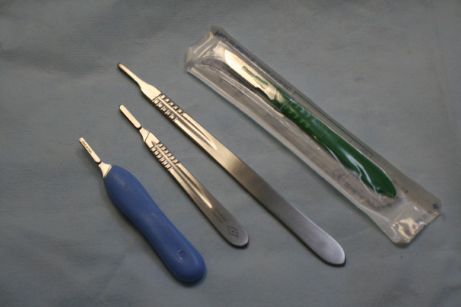 Surgical Scalpel Handles

• | Surgical quality stainless steel material.

Part No | Style | Handle Type | Quantity Per Case
SBHAND-04-SS | Fits # 20,21,22,23,24,25 blades | Solid | 1
SBHAND-04L-SS | Fits # 20,21,22,23,24,25 blades | Solid | 1
SBHAND-06-SS | Fits # 20,21,22,23,24,25 blades | Hollow | 1
SBHAND-08-SS | Fits # 60 and 70 blades | Hollow | 1
SBHAND-08P-PLAS | Fits # 60 and 70 blades | Comfort Grip | 1

 Forceps

• | Surgical quality stainless steel material.
• | Please call for details on any items not listed

Part No | Style | Quantity Per Case
FN-18337T | 2 X 3 Teeth; 5 1/2 | 1
FN-33-1044 | Dura Strip; 8 ½”; Pakistan | 1
FN-422-568 | Tissue; 2 X 3 Teeth; 6”; German | 1
FN-423-566 | Serrated Handles; 3 X 4 Teeth; 6” | 1
FN-423-608 | Ewald; Serrated Tips; 4 ¾” | 1
FN-425-181 | Russian; Tissue; Multi-Teeth; 8” | 1
MLTX-6-150 | Fonney Tissue; 7” | 1

Toll Free: 888-604-1004 27 www.centennialproducts.com

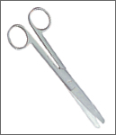 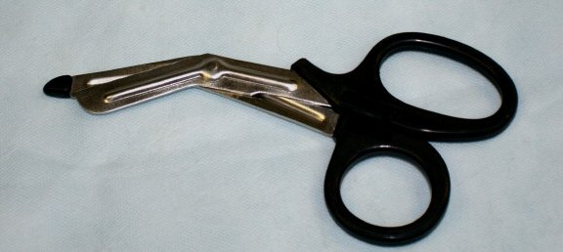 Scissors and Shears

• | Surgical quality stainless steel material.
• | Please call for details on any items not listed

Part No | Style | Quantity Per Case
FN-11149 | Doyen Scissors; Straight; 7” Pakistan | 1
FN182-006 | Utility Shears; Black Coated Handle; 7 ½” German | 1
FN103-267 | Iris Scissors; Curved; Sharp/Sharp; 4 ½”; German | 1
FN103-503 | Micro Iris Scissors; Curved; Sharp; 4”; German | 1
FN104-622 | Reynolds Dissecting Scissors; 7”; Tenotomy Tips | 1
FN106-567 | Mayo Dissecting Scissors; Curved; 5 ½”; German | 1
FN161-804 | Doyen Scissors; Straight; 7”; German | 1
FN965-558 | Enterotomy Scissors w/probe tips; 8”; German | 1
FN965-583 | GI Enterotomy Scissors; Hook Blade; 8” | 1
FN-S10-608MD | Scissors; Straight; Blunt/Blunt; 6 ½” | 1
FN-GS15-579MD | Mayo Dissecting Scissors; Straight; 6” | 1
RBZ-RS-6872L | Mayo Scissors; Straight; 6 ¾”; Left Hand | 1
RBZ-RS-6952L | Metzenmaum Scissors; Straight; 7”; Left Hand | 1

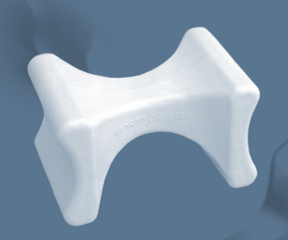 Adjustable Head Rest

• | Molded from chemical resistant plastic. Reusable. Easily cleaned with soap and water.
• | Wider based legs allow for more table contact for added stability and less slippage.

Part No | Style | Quantity Per Case
MOR-LW390 | White/ Adjustable up to six positions | 1

Toll Free: 888-604-1004 28 www.centennialproducts.com

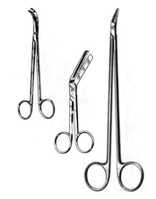
  - Forceps / Clamps  - Post Mortem Instruments  - Retractors  - Scissors | Available in a variety of sizes and styles. Please call for details.

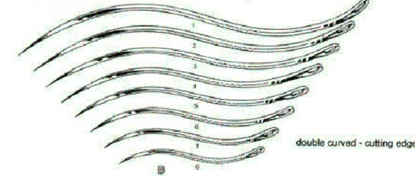
  - Post Mortem Needles
  B. Double Curve Cutting Edge Sizes 1-8
  12 Per Package

Toll Free: 888-604-1004 29 www.centennialproducts.com

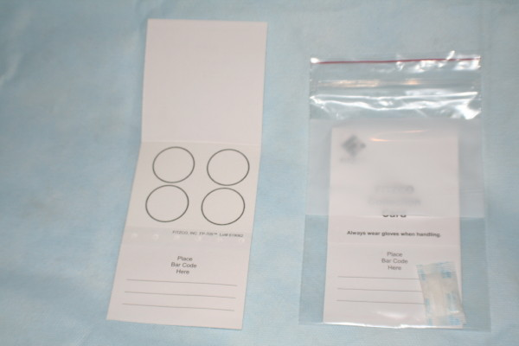 DNA Blood Collection Card

• | Standard body fluid specimen collection and transport paper for either immediate clinical diagnostic testing or archival purposes (non-treated) FP705 Paper
• | Registered as a Class II Medical Device and meets the standards set by the National Committee on Clinical Laboratory Standards

Part No | Style | Quantity Per Case
DNA-10538414FITZ | 4 Circles w/ Name and Date Areas | 100
DNA-10538414KIT | Card w/ Desiccant Pack and 4X6 Ziplock Bag | 100

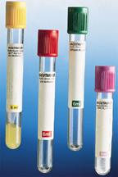 Serum Tubes

• | Many Types Available
• | Call customer service for your individual needs

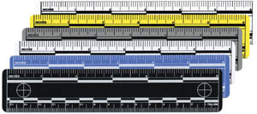 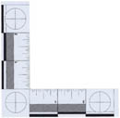 Rulers

• | L-Shaped printed in inches on laminated plastic with non-glare finish
• | Flexible non-glare vinyl marked in both inches and millimeters

Part No | Style | Quantity Per Case
TT-PSP-L | L-Shaped Photo Scale; 4 X 4” | 1
TT-PSP-GB | Vinyl; Gray w/black print; 6” | 10

Toll Free: 888-604-1004 30 www.centennialproducts.com

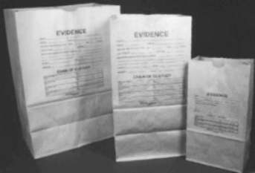 Paper Evidence Collection Bags

• | Bags are preprinted and include all the information required for proper evidence submission to the crime laboratory, including a chain of custody section
• | These evidence bags are made from a heavy-duty kraft paper stock, which is "breathable", and makes them ideal for a wide variety of evidence - from clothing containing body fluids to damp marijuana

Part No | Style | Quantity Per Case
EVDBAG-EPB-S | 5 ¼ X 10 ¾ X 3 ½ | 100
EVDBAG-EPB-M | 7 X 13 ¾ X4 ½ | 100
EVDBAG-EPB-L | 12 X 17 X 7 | 100

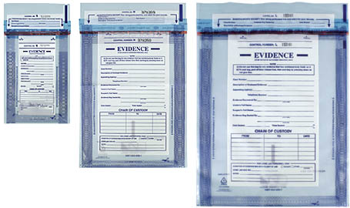 Plastic Evidence Collection Bags

• | Heavy-duty polyethylene evidence bags require no prepackaging of evidence prior to use. The instantaneous adhesive closure strip is permanent and impossible to open without destroying the seal.
• | Includes white write-on area, tear and puncture resistance durability, pre-printed control numbers and the convenience of clear see through material.

Part No | Style | Quantity Per Case
EVDBAG-EBS-PL | 5 X 8 CHAIN OF CUSTODY | 100
EVDBAG-EBM-PL | 9 X 12 CHAIN OF CUSTODY | 100
EVDBAG-EBL-PL | 12 X 15 CHAIN OF CUSTODY | 100

 Crime Scene Barrier Tape

• | 3” wide, 1000’ long roll comes in a crush-resistant cardboard dispenser box for easy dispensing and storage.

Part No | Style | Quantity Per Case
EVDBRTAPE-BT-CS-W/O | YELLOW W/BLACK LETTERS | 1

Toll Free: 888-604-1004 31 www.centennialproducts.com

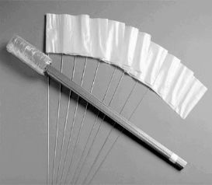 Evidence Flags

• | Each 4 x 5” flag comes attached to a 24” PVC stake

Part No | Style | Quantity Per Case
EVDFLAG-4100O | Blank Orange | 50
EVDFLAG-4100Y | Blank Yellow | 50
EVDFLAG-4100R | Blank Red | 50
EVDFLAG-4115EO | “Evidence” Orange | 50
EVDFLAG-4115EY | “Evidence” Yellow | 50

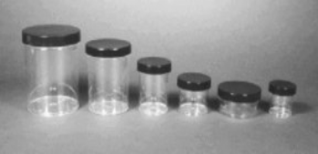 Evidence Collection Jars

• | Clear plastic wide mouth evidence jars.

Part No | Style | Quantity Per Case
TT-JAR1PS | Polystyrene; Screw lid; Solids; 1 oz | 15
TT-JAR2PS | Polystyrene; Screw lid; Solids; 2 oz | 15
TT-JAR4PS | Polystyrene; Screw lid; Solids; 4 oz | 15
TT-JAR16PS | Polystyrene; Screw lid; Solids; 16 oz | 15
TT-JAR24PS | Polystyrene; Screw lid; Solids; 24 oz | 15
TT-JAR32PS | Polystyrene; Screw lid; Solids; 32 oz | 15

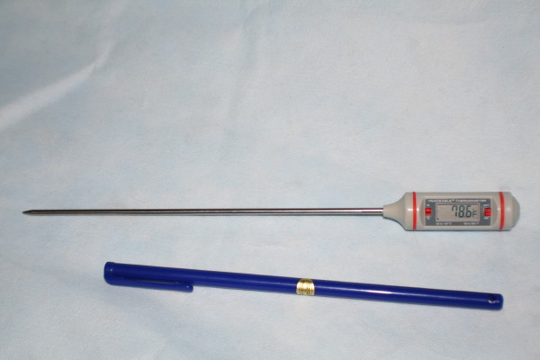 Post Mortem Thermometers

• | Digital stainless steel thermometer, accuracy +/- 1c

Part No | Style | Quantity Per Case
FS-15078J | 8” Probe/ 11” Overall | 1

Toll Free: 888-604-1004 32 www.centennialproducts.com

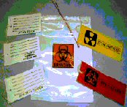 Centennial Body Bag ID Kit

• | Resealable self adhesive Ziplock pouch for paperwork. Each Tyvek tag is made with reinforced eyelets.
• | 1 Red Bio-hazard tag, 1 Yellow Contamination tag, 1 White Toe tag, 1 White Personal Effects tag and 1 White Exterior of Pouch tag.

Part No | Quantity Per Case
BBID-KIT-T | 24

 Easy “Write On” Metal ID Tag

• | Metal tag with attached wires. Ideal for use in extreme environmental conditions.
• | Soft metal allows use of almost any marking or writing implement including wood stick, keys, etc.

Part No | Quantity Per Case
TAG-METAL-01 | 200

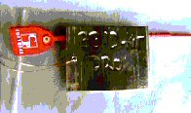 Easy “Write On” Metal ID Tag Kit

• | Kit consists of TAG-METAL-01 above without the ties and a serialized plastic tamper resistant seal.
• | Each kit packed in individual Ziploc bag

Part No | Quantity Per Case
BBID-KIT-DR01 | 50

Toll Free: 888-604-1004 33 www.centennialproducts.com

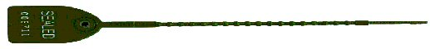
Serial Numbered Tamper Resistant Body Bag Seal

• | 8” Long red numbered plastic ID tag designed to fit Centennial Products Body Bag Zippers
• | Sequentially numbered lots of 50. Custom number series available (1,000 piece minumum)

Part No | Quantity Per Case
TAG-CENTSEAL | 50

** Custom numbers and logos have a 6-8 week lead-time **

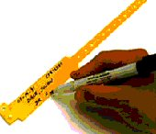
Write-On Wrist or Ankle ID Bands

• | Write-On band with “Use Once” permanent snap style closure
• | Each case (500) of MC-01-4440-W packed with marking pen
• | Available in vinyl or poly-pro material
• | Variety of colors available in full case quantities
• | 5040 band w/custom imprint, 1000 piece minimum order

Part No | Style | Color | Quantity Per Case
MC-01-4440-W | VINYL | WHITE | 500
MC-01-5040-W | POLY-PRO | WHITE | 500
MC-01-5040W-C | POLY-PRO | WHITE | 1000

Toll Free: 888-604-1004 34 www.centennialproducts.com

CENTENNIAL PRODUCTS, INC.
6900 Philips Hwy, Suite 45 (32216)
P. O. Box 23905
Jacksonville, FL 32241
Customer Service: (888)604-1004
Administration: (904)332-0404 Fax: (904)332-0404
www.centennialproducts.com E-mail: sales@centennialproducts.com

TERMS AND CONDITION OF SALE

Centennial Products, Inc. accepts C.O.D., Visa/MasterCard, and American Express credit cards. Open account terms (upon approval of credit) are 1% 10 days (from date of invoice) Net 30.

Freight
Freight is FOB our warehouse in Eagle Pass, TX or Jacksonville, FL or point of origin of shipment unless other arrangements have been made. All drop shipments and air shipments will be charged freight.

Returns
Returns and exchanges must have prior authorization from Centennial Products, Inc. Product must have been purchased within 6 months prior to the date of the return and must be in new condition.

All returns may be subject to a 20% restocking charge

All returns are to be shipped freight prepaid.

Upon inspection of the returned product, a credit memo (less any restocking fee), will be issued if all product returned is in new and saleable condition.

Damage
Damage by freight carriers should be reported to the carrier immediately. Once the goods are picked up by the freight carrier, the product becomes the customer’s responsibility and the customer should make a claim with the carrier immediately.

Changes
Centennial Products, Inc. reserves the right to change product specification, quantity, design or pricing without notice and without liability. While every precaution has been taken in the preparation of the catalog or price lists, Centennial Product, Inc. assumes no responsibility for errors and omissions.

Pricing
All prices are subject to change without notice.

Sales Tax
Centennial Products Inc. collects sales tax for Florida, Georgia, Indiana and Texas. A sales tax exemption certificate must be on file to be exempt from sales tax in the state the product is shipping to.

Foreign Orders
Foreign orders require prepayment. Prepayment must be in the form of a certified bank check; subject to terms and conditions of CPI’s bank. Export will be the responsibility of the customer or their export company. Shipment of product will be to the export facility in the continental United States.



 | Centennial Products, Inc.  Address: 6900 Phillips Highway, Suite 41, Jacksonville FL 32216  Mail Address: P.O. Box 23905, Jacksonville FL 32241-3905  Toll Free (888) 604-1004 • Fax (904) 332-0406 • Ph: (904) 332-0404  Internet: centennialproducts.com Email: sales@centennialproducts.commailto:sales@centennialproducts.com

Cent-030109

